**VISVESVARAYA TECHNOLOGICAL UNIVERSITY**

**“JnanaSangama”, Belgaum -590014, Karnataka.**



**PROJECT WORK-1 REPORT**

**on**

**Department Faculty Self-Assessment Report Submission System**

***Submitted by***

**HARSHIL DOSHI B (1BM19CS057)**

**HEMANG SINGH (1BM19CS061)**

***Under the Guidance of***

|  |  |
| --- | --- |
| **Prof. Bhoomika A P**  **Assistant Professor ,BMSCE** |  |

***in partial fulfillment for the award of the degree of***

**BACHELOR OF ENGINEERING**

***in***

**COMPUTER SCIENCE AND ENGINEERING**



**B.M.S. COLLEGE OF ENGINEERING**

**(Autonomous Institution under VTU)**

**BENGALURU-560019**

**Sep-2020 to Jan-2021**

**B. M. S. College of Engineering,**

**Bull Temple Road, Bangalore 560019**

(Affiliated To Visvesvaraya Technological University, Belgaum)

**Department of Computer Science and Engineering**

  

**CERTIFICATE**

This is to certify that the project work entitled “**Department Faculty Self-Assessment Report Submission System**” was carried out by **HARSHIL DOSHI B (1BM19CS057), HEMANG SINGH (1BM19CS061)** who are bonafide students of **B. M. S. College of Engineering.** It is in partial fulfillment for the award of **Bachelor of Engineering in Computer Science and Engineering** of the Visveswaraiah Technological University, Belgaum during the year 2020-2021. The project report has been approved as it satisfies the academic requirements in respect of **Project Work-1 (19CS3PWPW1)**work prescribed for the said degree.

Signature of the Guide                 Signature of the HOD

Prof.Bhoomika A P Dr. Umadevi V

Assistant Professor Associate Prof.& Head, Dept. of CSE

BMSCE, Bengaluru BMSCE, Bengaluru

External Viva

Name of the Examiner                                                                                       Signature with date

1._____________________________ ________________________

2. _____________________________ _________________________

**B.M.S. COLLEGE OF ENGINEERING**

**DEPARTMENT OF COMPUTER SCIENCE AND ENGINEERING**



***DECLARATION***

We, HARSHIL DOSHI B (1BM19CS057), HEMANG SINGH (1BM19CS061), students of 3rd Semester, B.E, Department of Computer Science and Engineering, B. M. S. College of Engineering, Bangalore, hereby declare that, this Project Work-1entitled "Department Faculty Self Assessment Report Submission System" has been carried out by us under the guidance of Bhoomika A P, Assistant Professor, Department of CSE, B. M. S. College of Engineering, Bangalore during the academic semester Sep-2020-Jan-2021

We also declare that to the best of our knowledge and belief, the development reported here is not from part of any other report by any other students.

Signature

Harshil Doshi B (1BM19CS057)

Hemang Singh (1BM19CS061)

**1. Introduction**

Website development for “Department Faculty Self Assessment Report Submission System”

This self-assessment report helps a faculty in improving in the areas in which they think that they are not good.

Self evaluation helps the faculty to tell the truth to himself /herself.

The Self-Assessment Checklists are designed to assist BMSCE College faculty in identifying individual teaching strengths and needs with respect to the competencies identified in the Professor of the 21st Century Framework

1. **The Faculty Self-assessment supports following users**

* College Faculty
* Guest Users From Other Colleges or Aspiring Teachers
* College Admin Login
* **Functionalities Under Faculty Login**
* College faculty can assess themselves
* By giving this test they can check how prepared they are for the online classes
* Display 6 question under 3 different categories
* The result will be sent to them through mail
* **Functionalities Under Guest Login**
* Guest users can assess themselves
* While logging they will be asked for their contact details so that they can be contacted as per the need
* By giving this test they can check how prepared they are for the online classes
* Display 6 question under 3 different categories
* The result will be sent to them through mail
* **Functionalities Under Admin Login**
* Admin can check the details and the score of all the members who have given the test
* He will get a detailed score of all the participants and can keep a check on everyone’s performance

1. **Design Layouts: ScreenShots of Webpages**
   1. **Home Webpage**

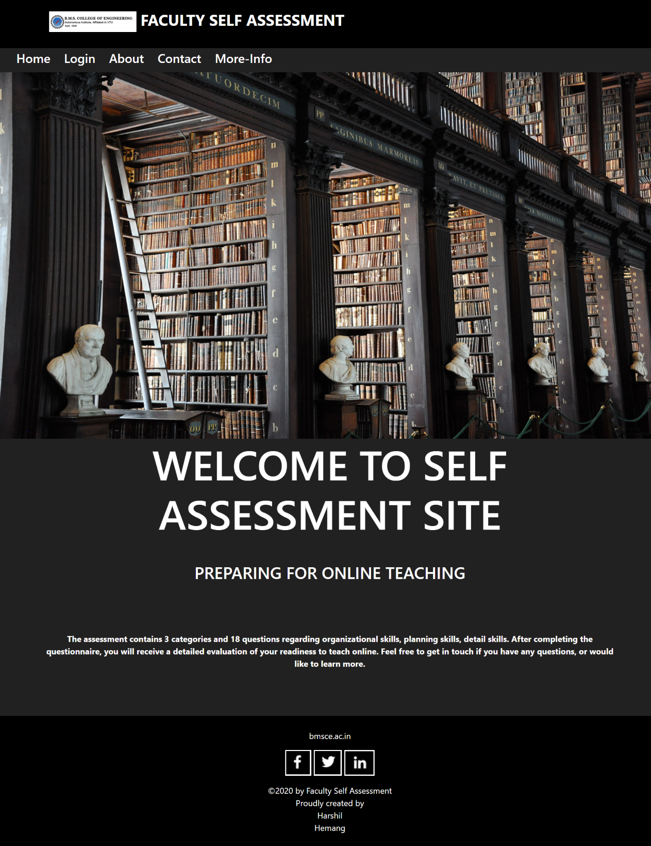

**3.2: Login Webpage**

**3.2.a: Faculty Login**

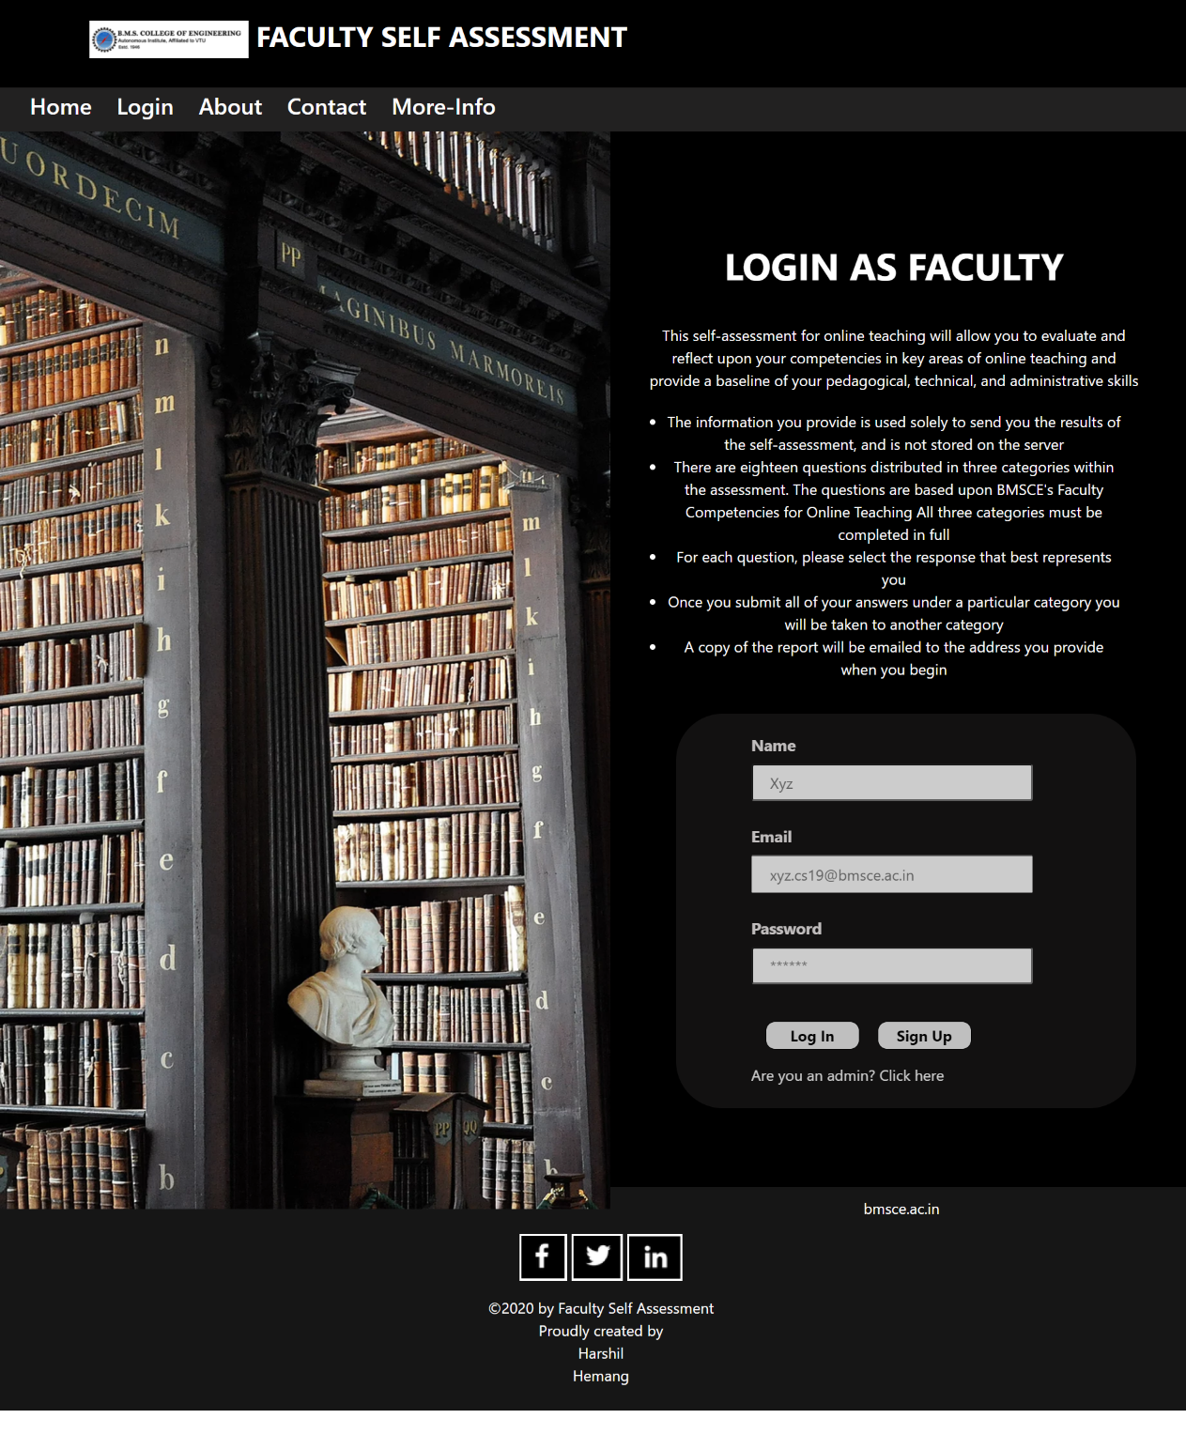

**3.3.b: Guest Login**

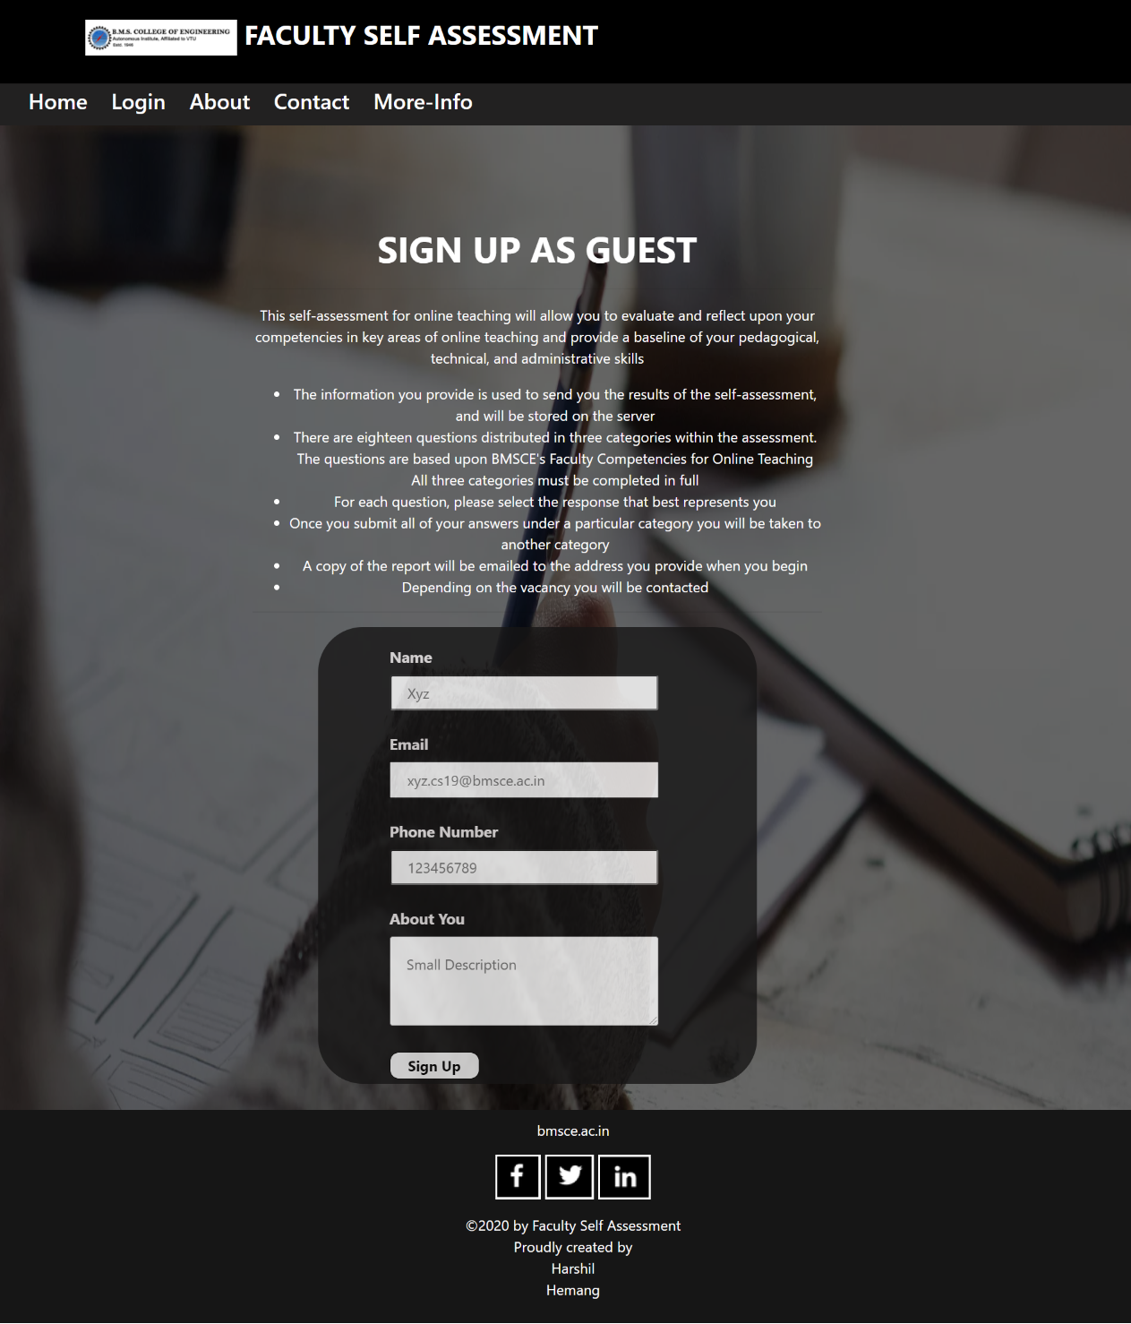

**3.4.c: Admin Login**

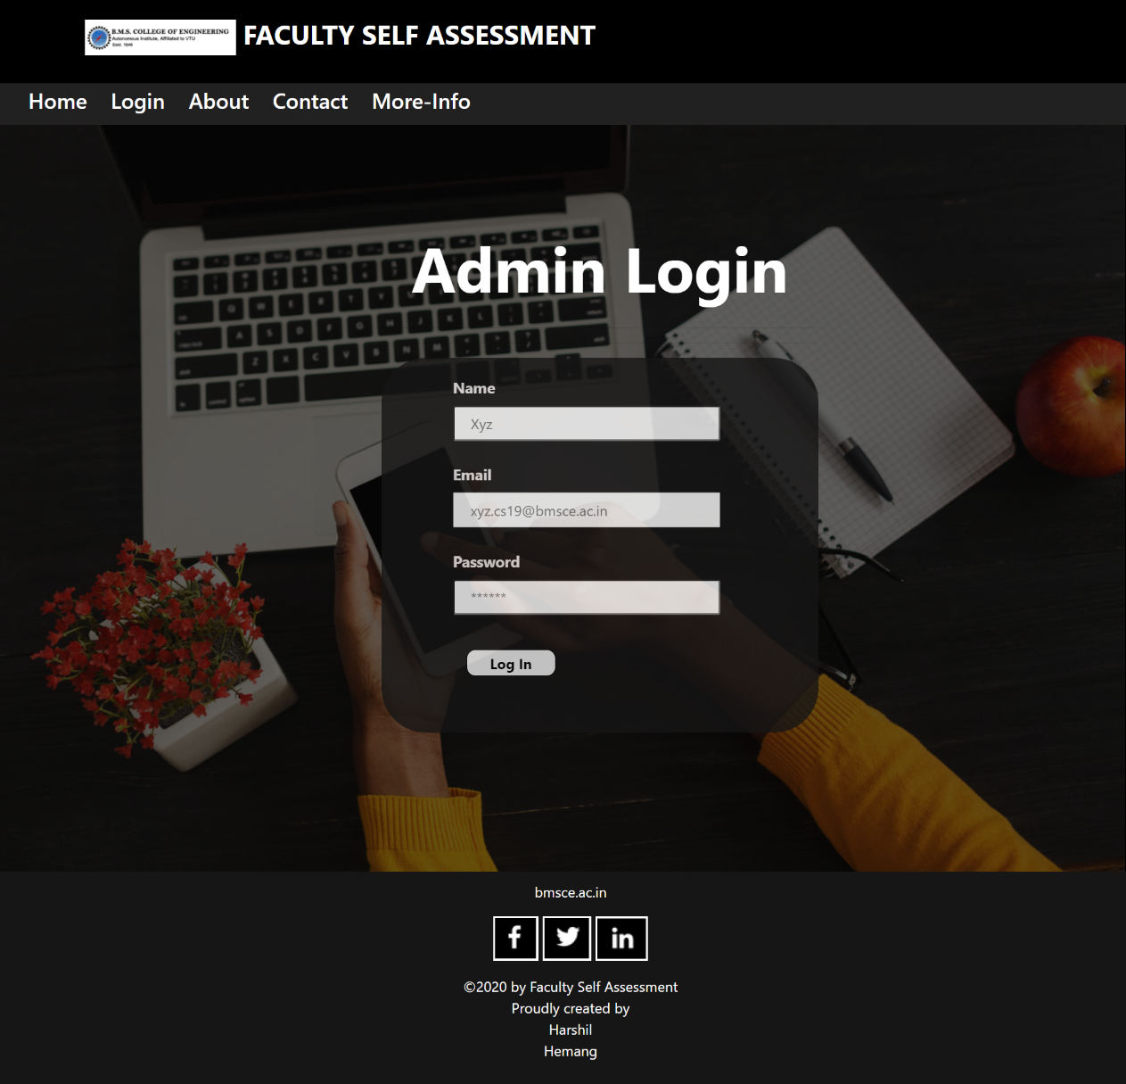

**3.5. Faculty Self-Assessment Questions display Webpage**

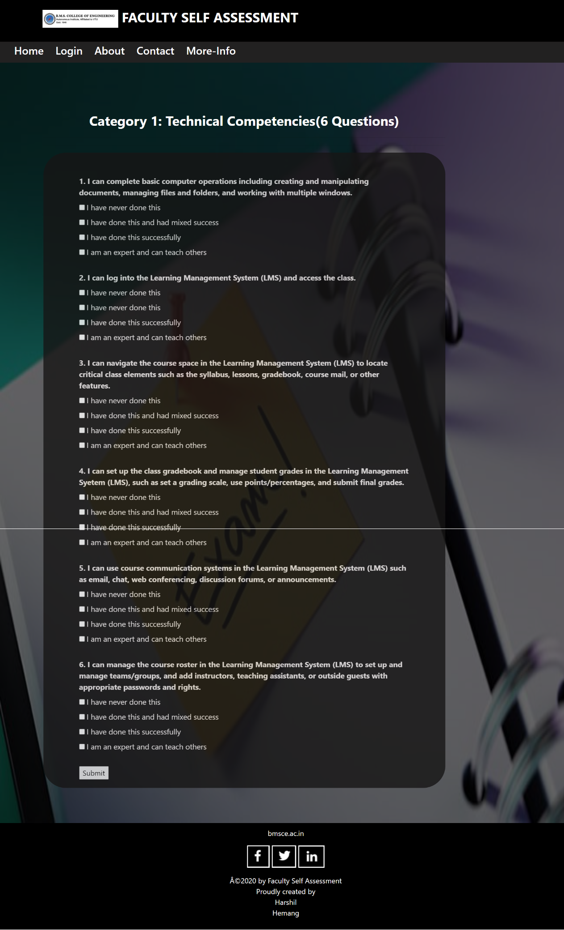

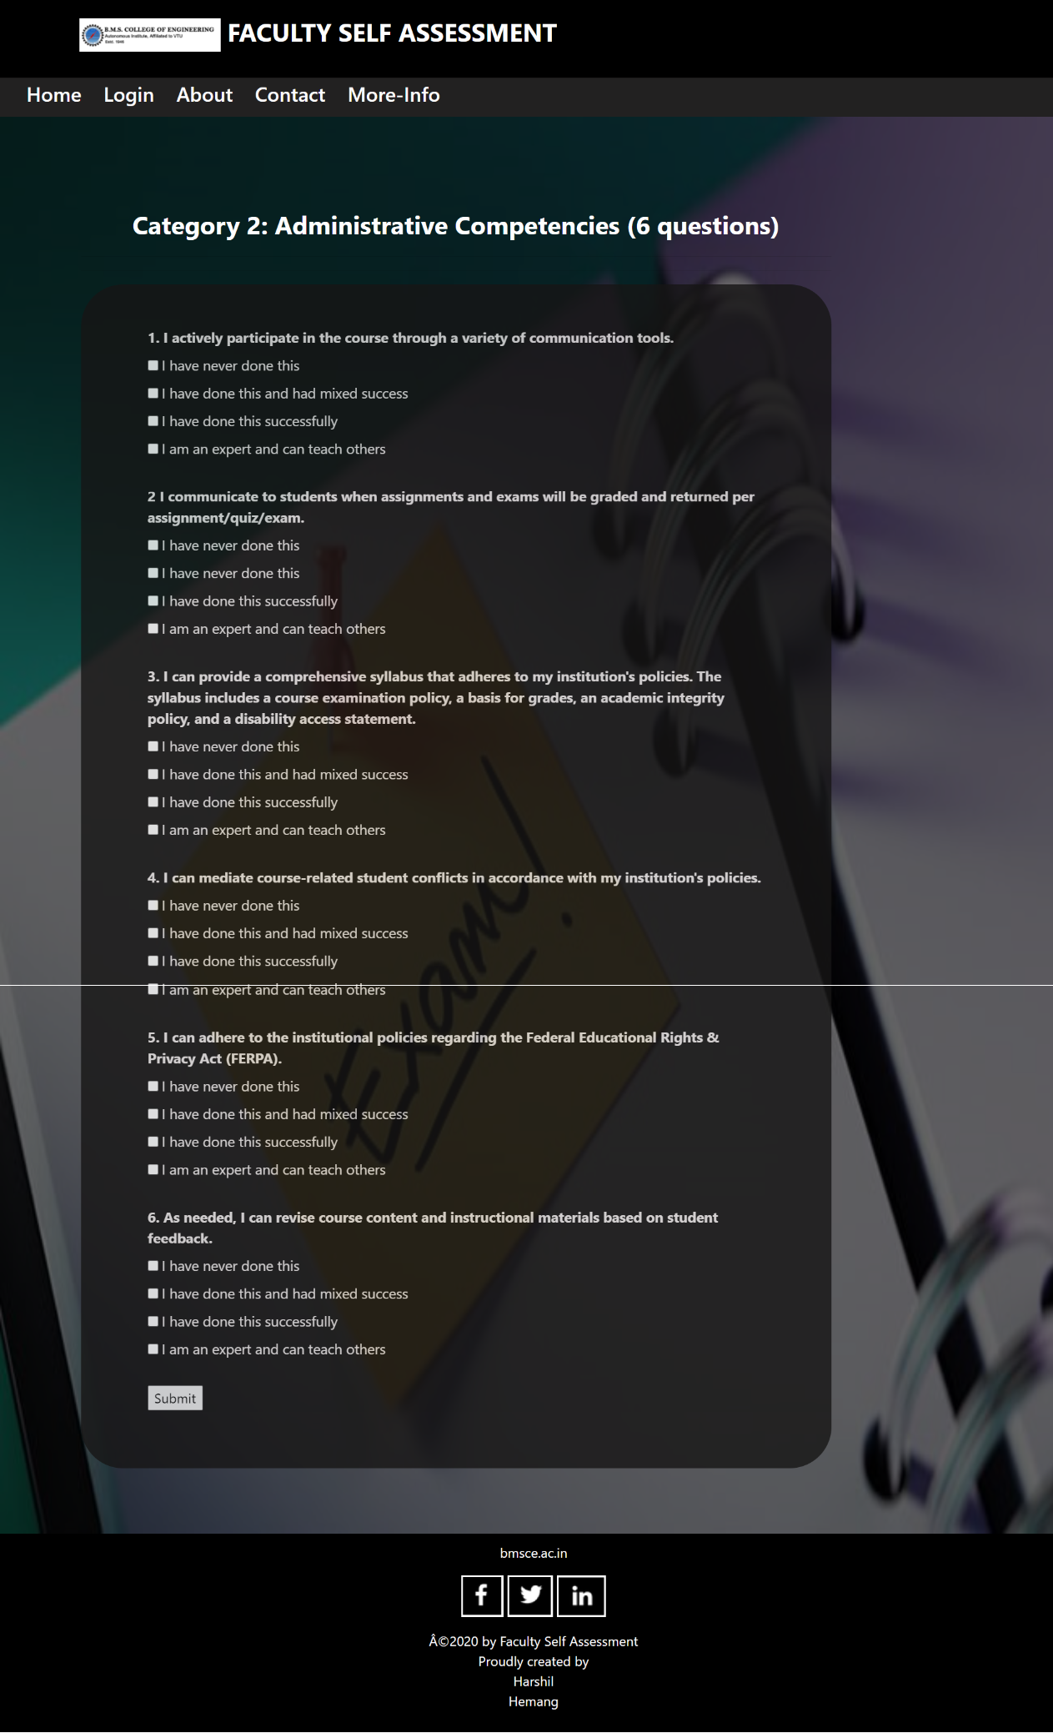

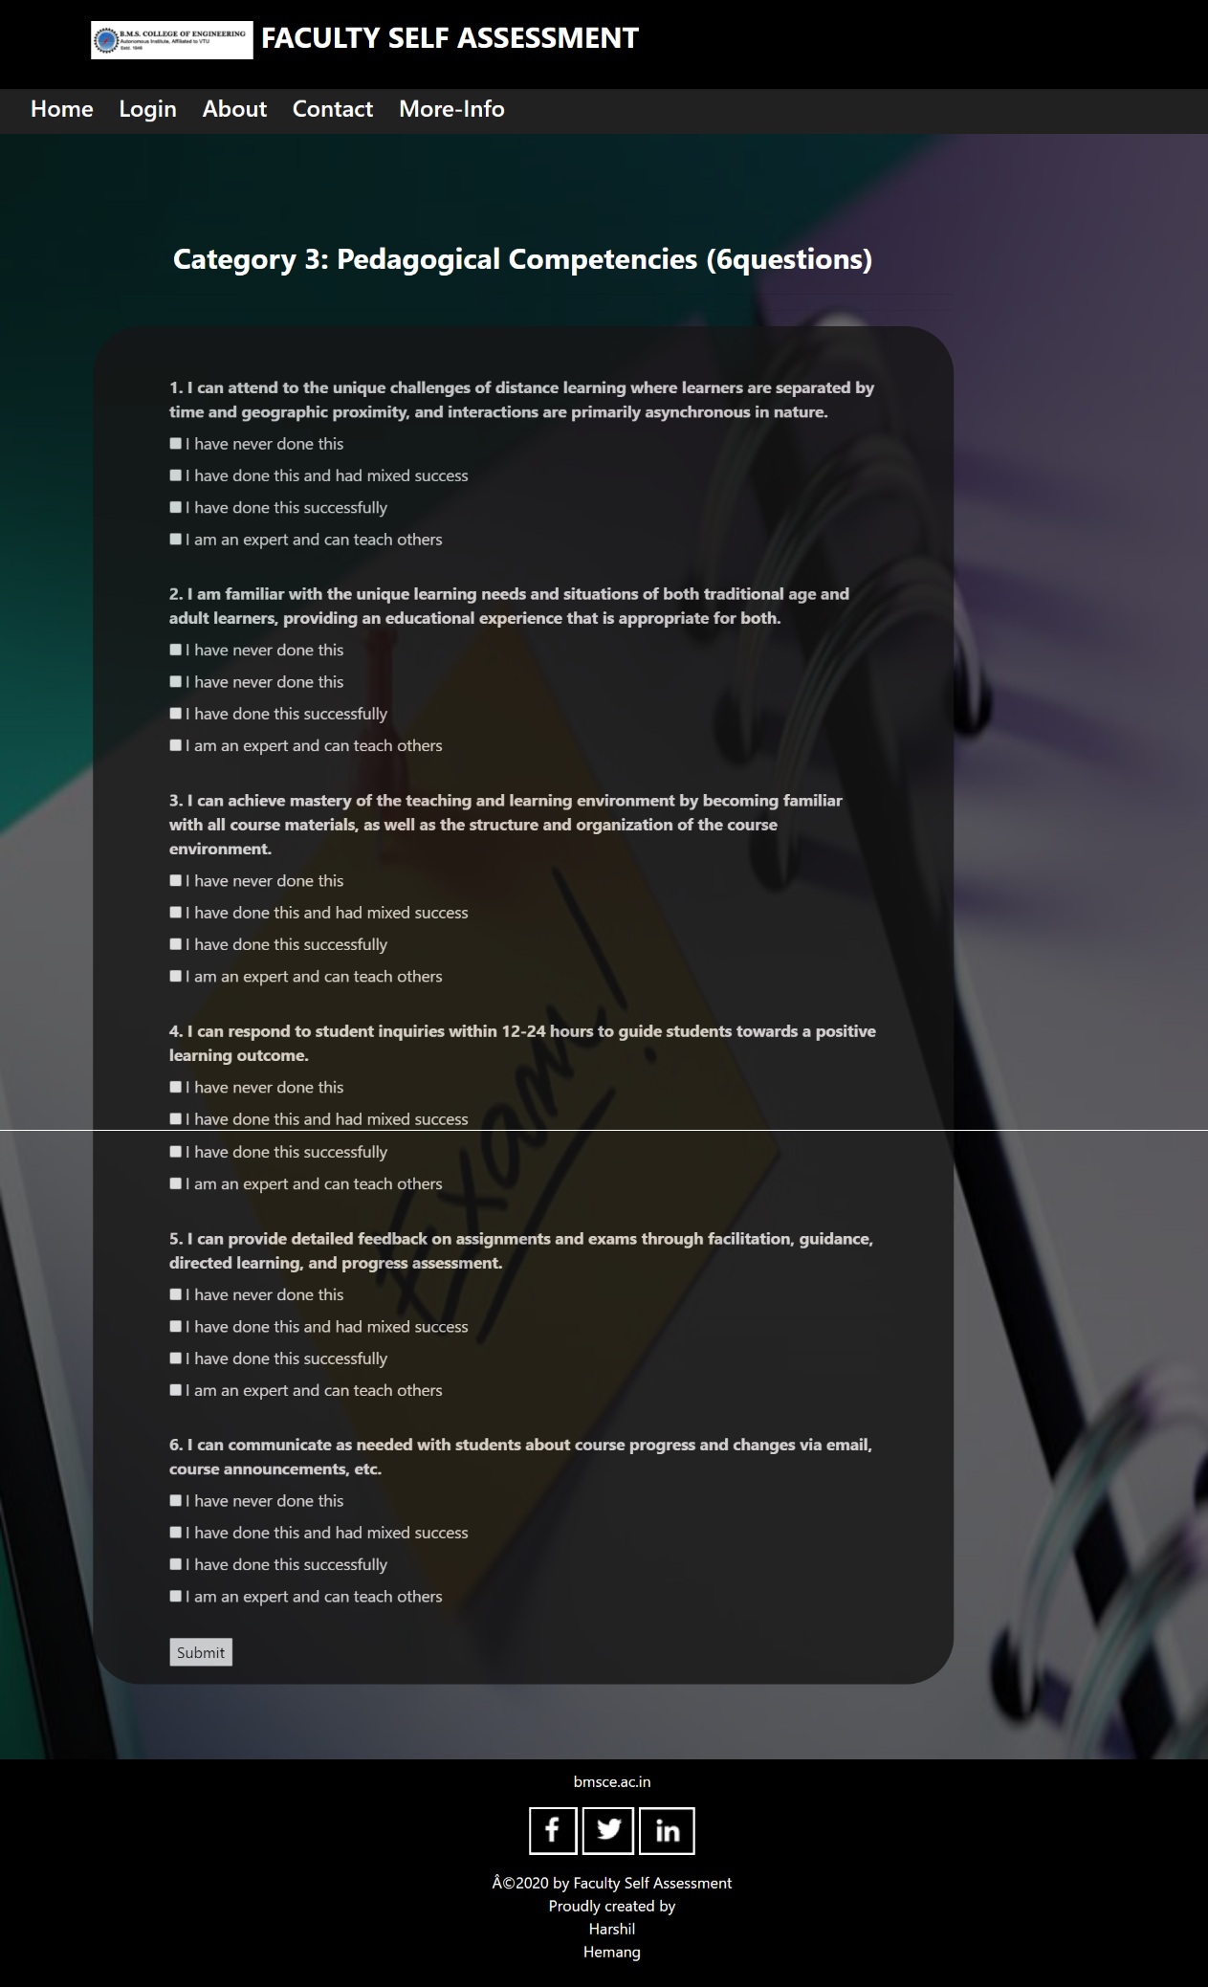

**3.6. Response Display Webpage**

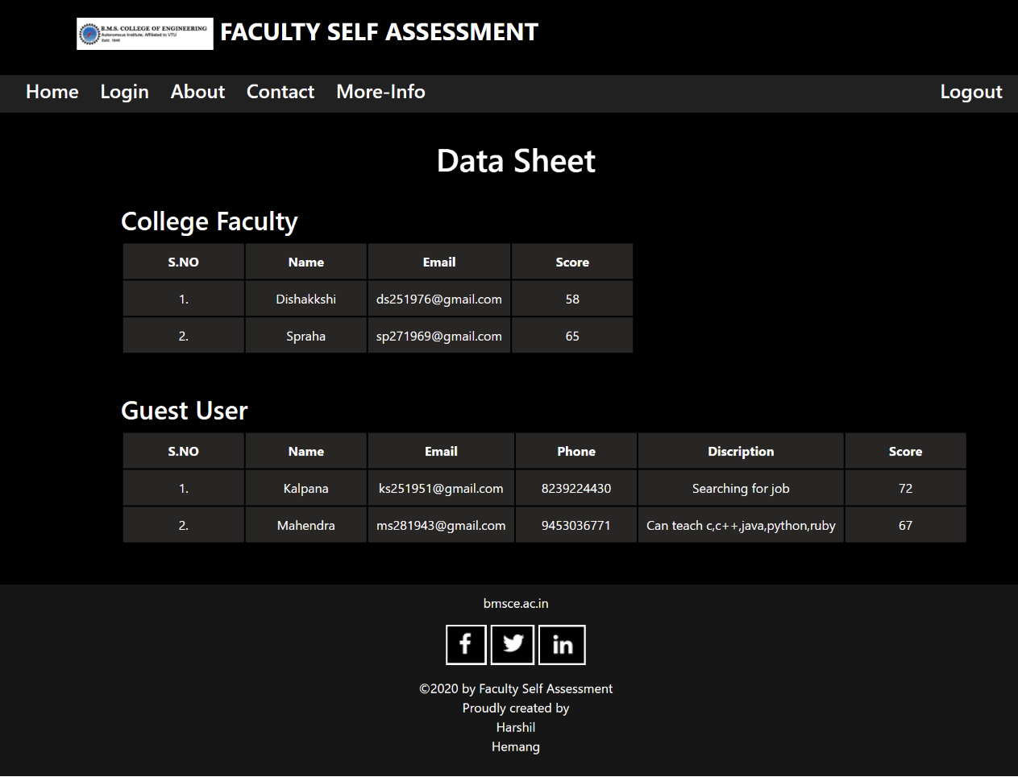

**3.7. More about Website**

